Waterstone Clinic

Socrates GP eReferrals Mini Guide

This user guide summarises how the GP eReferral process works when referring to Waterstone Clinic via the Socrates GP application.

For Socrates support queries please call 071 – 919 3600 followed by option 1, or email support@clanwilliamhealth.com

Step #1
Open the ‘Documents’ section of the patient’s chart and click ‘E-Referrals’.
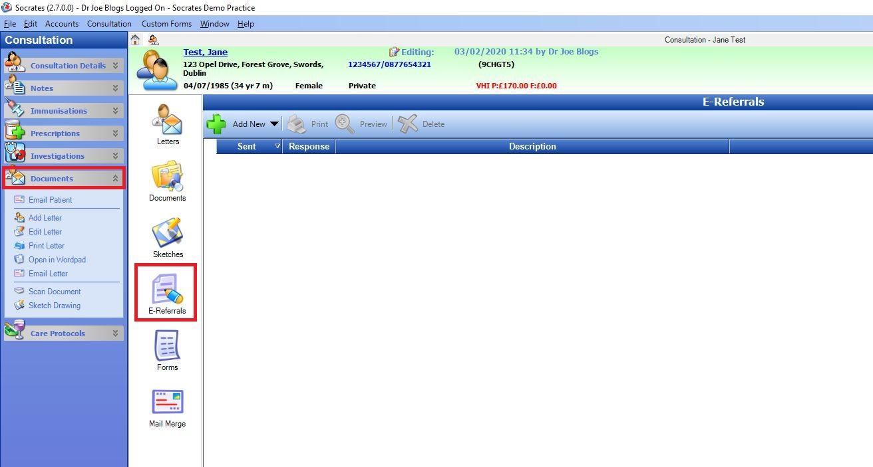

Step #2
Click ‘Add Referral’ and then click the ‘Healthlink Referral’ button.
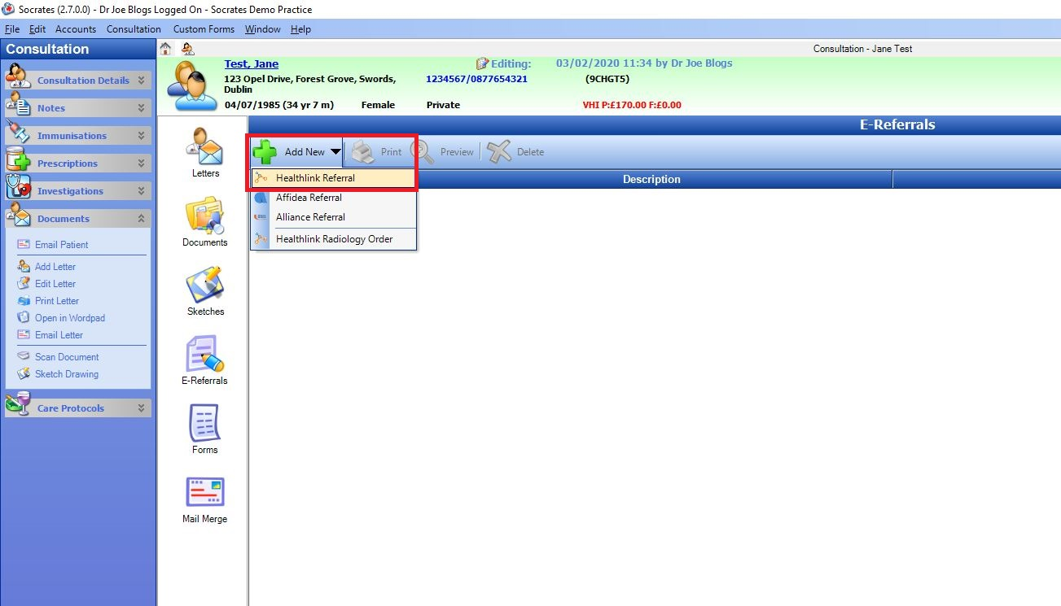

Step #3
Select Hospital Type ‘Private’.
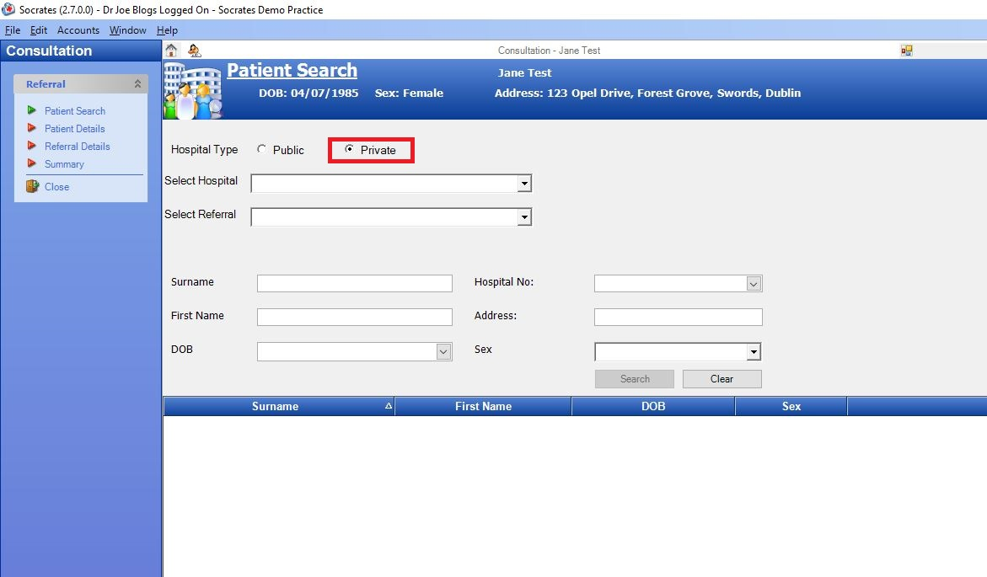

Step #4
Click the ‘Select Hospital’ list and select Waterstone Clinic.
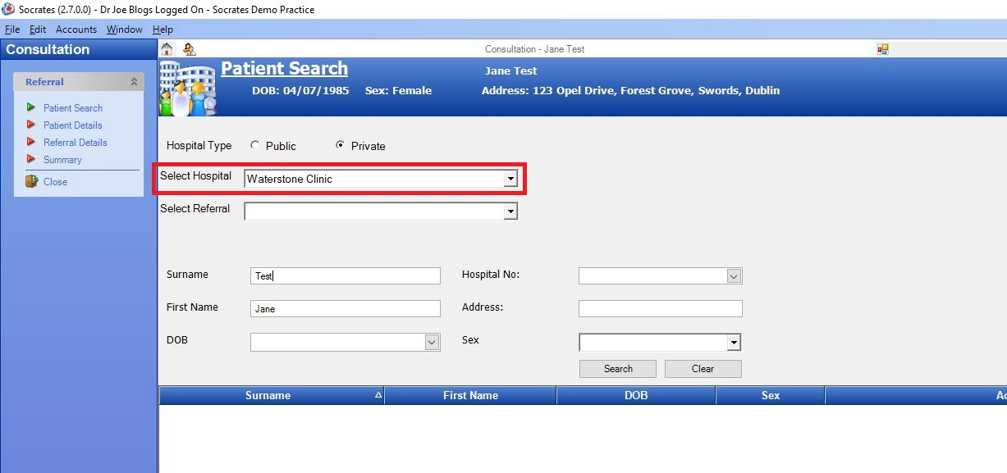

Step #5
Click the ‘Select Referral’ list to choose what type of referral (location/service) you wish to send the patient for, e.g. Dublin Waterstone Clinic Referral.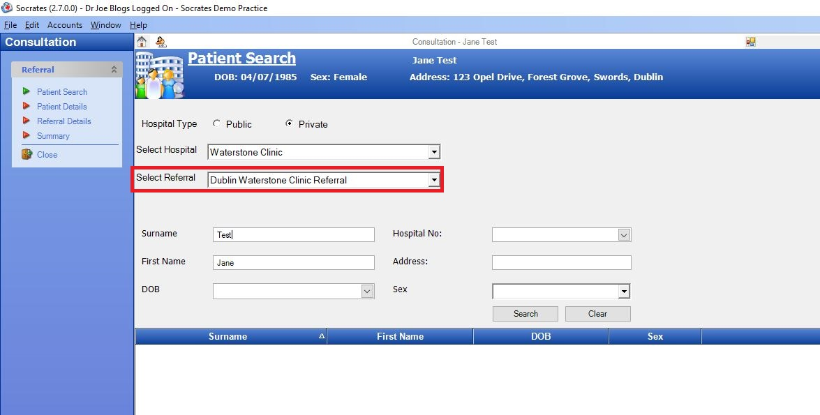

Step #6
Click the ‘Create New Patient’ button in the bottom right corner, followed by ‘Next’ on the following screen.
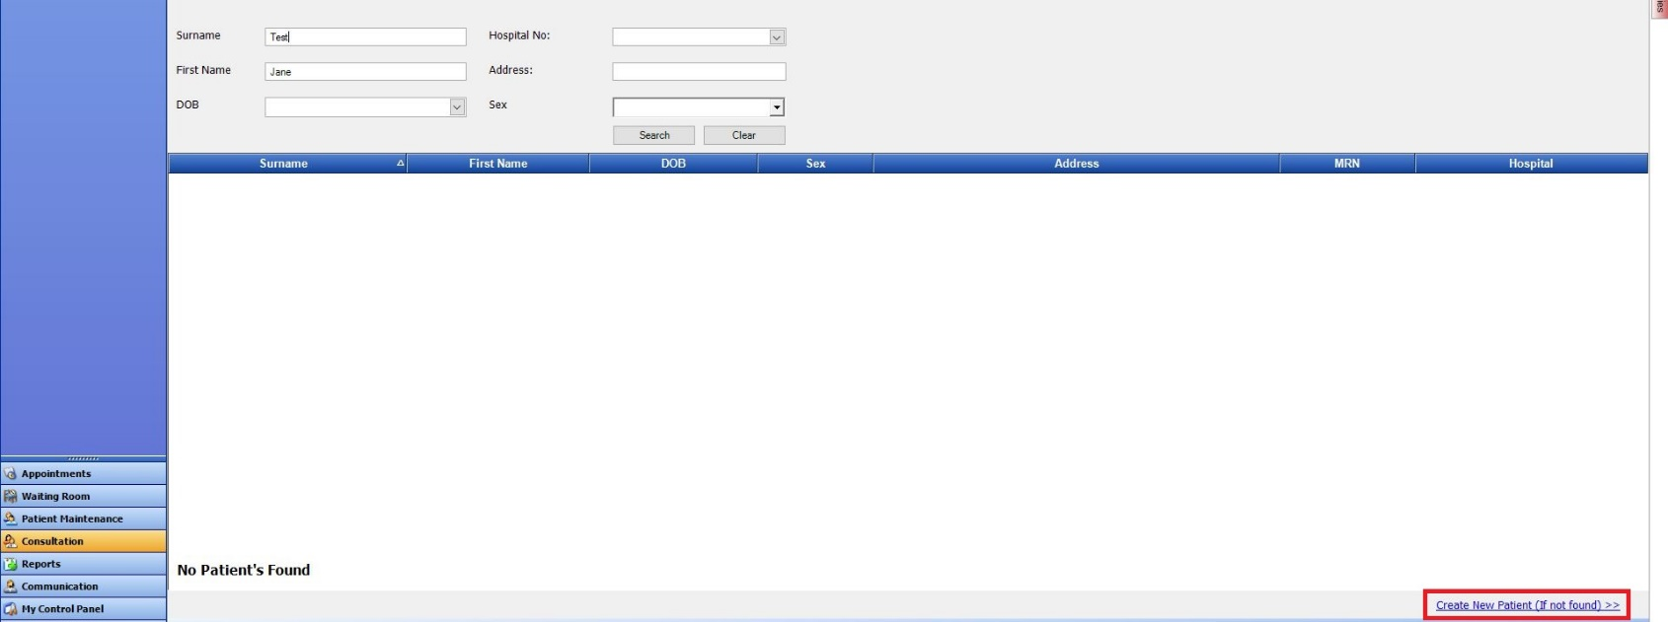

Step #7
The ‘National Standard Refrerral Form’ will load up. Fill in the patient referral information as normal.
Note: demographic and clinical information, such as past medical history, medications, etc, that have already been saved in the patient’s chart will automatically populate the appropriate sections of the letter, meaning additional work/typing is kept to a minimum.
When all referral information has been filled in click ‘Next’ in the bottom right corner.
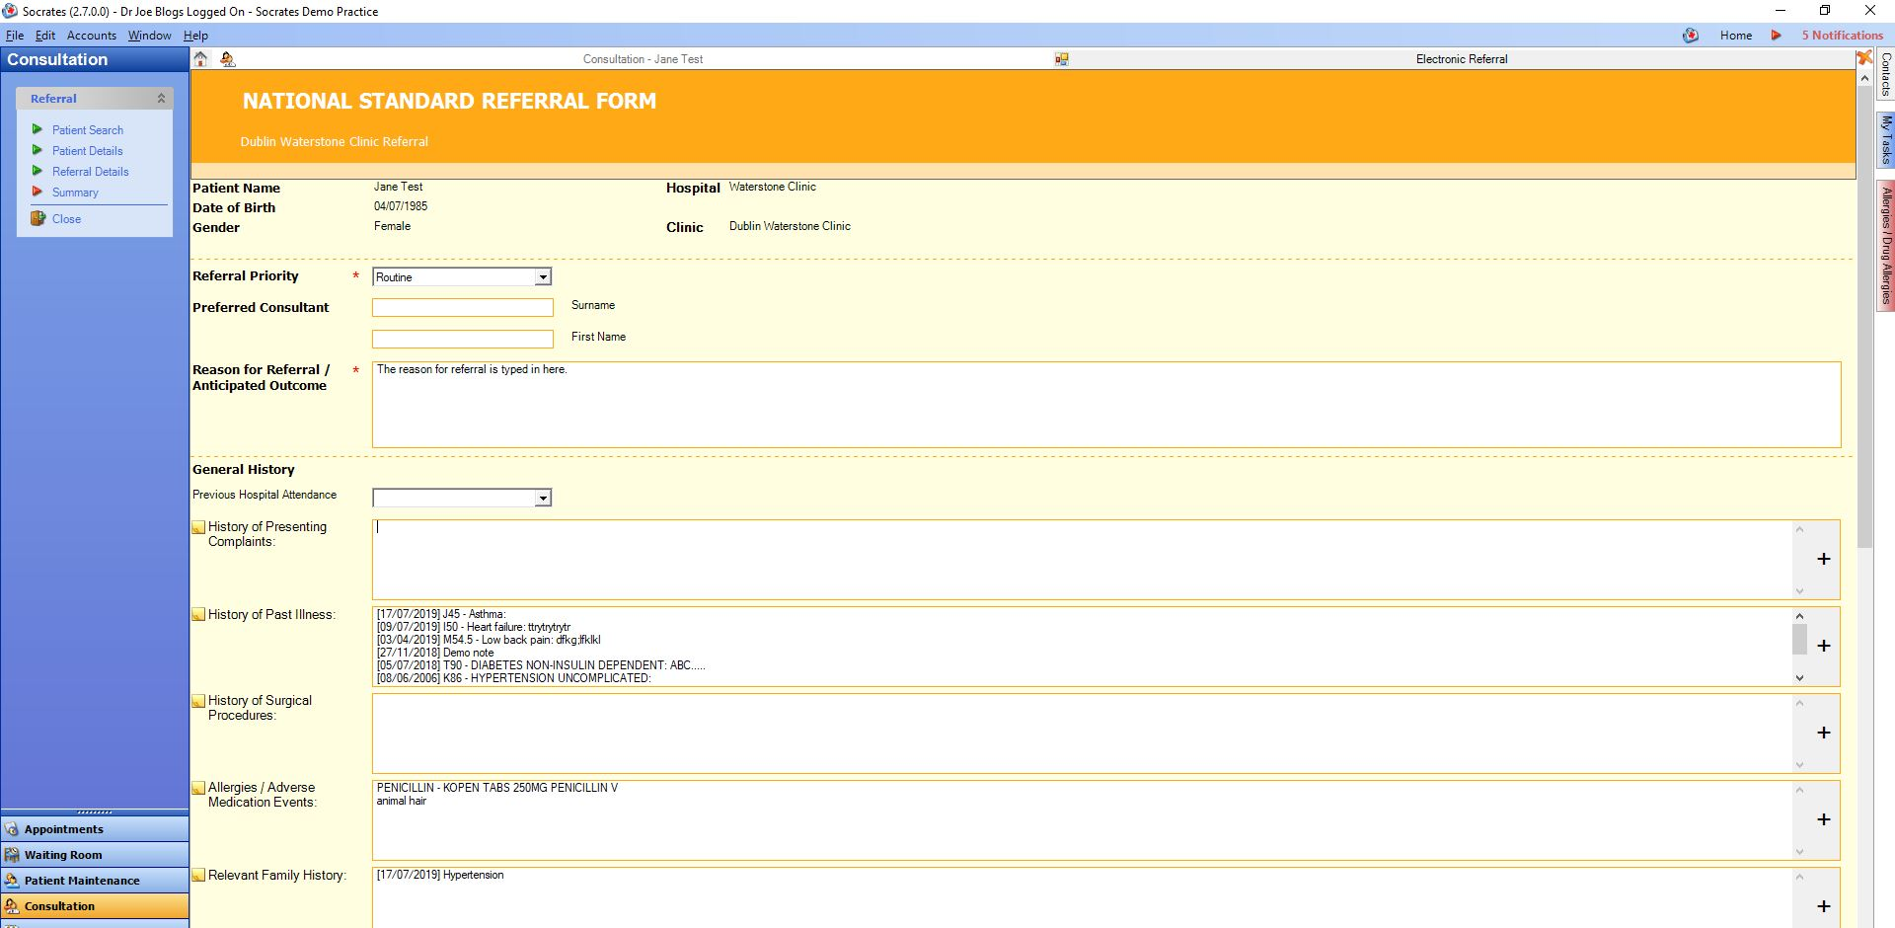
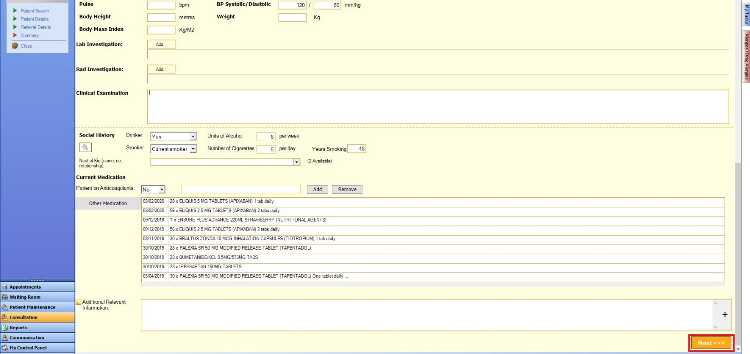

Step #8
An A4 preview of the letter will appear on screen, which you can review to make sure you are happy with the referral before sending it. If you wish to edit it, you can do so by clicking the ‘Back’ button in the bottom right corner. When you are ready to send it click the ‘Submit’ button in the bottom right corner.
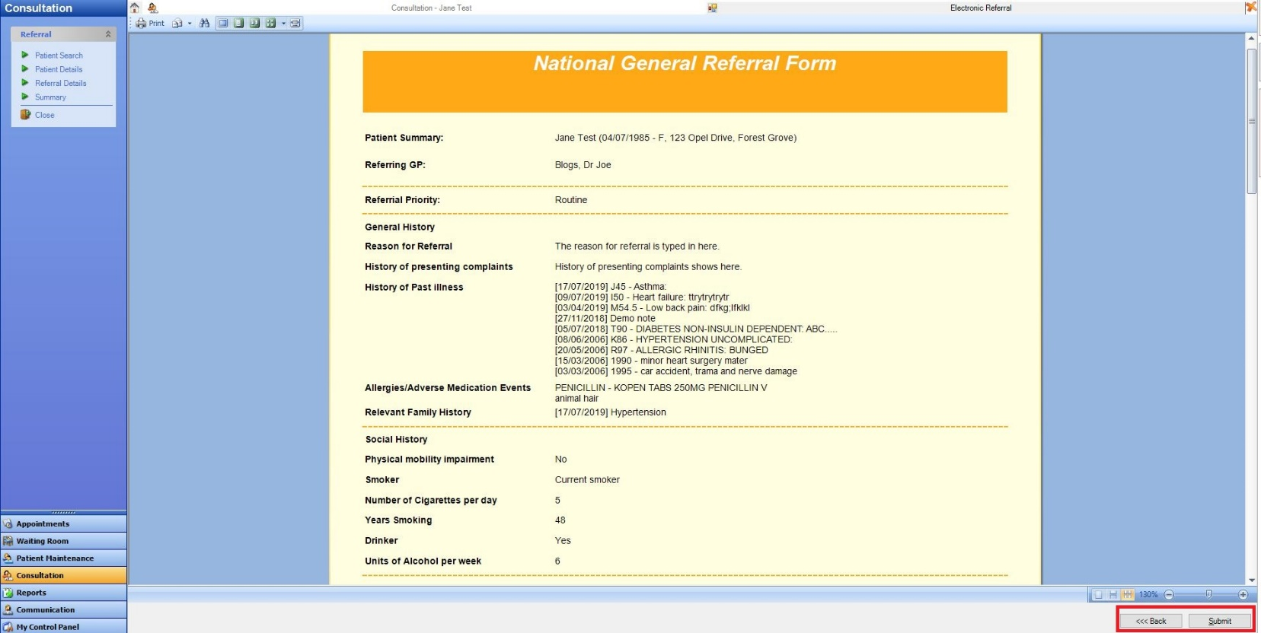

The referral will take approximately 3 seconds to deliver and will appear in the Waterstone Clinic booking office in real time where it will be triaged as normal. In the patient’s chart the status of the referral will change to ‘Delivered’.
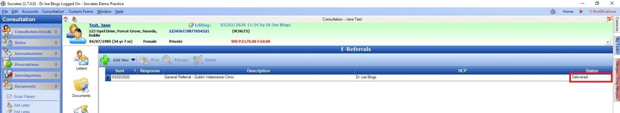

Viewing Response Messages from Waterstone Clinic

Option 1 – View response in the patient’s chart

If a referral response message is sent by Waterstone Clinic to the practice (via the Healthlink Online Portal) the status of the referral in the patient’s chart will change to ‘Response Received’.
On the left hand side of the screen you will see a ‘Sent’ date and a ‘Response’ date. The sent date is the date the referral letter was sent, and the response date is the date the response was received.
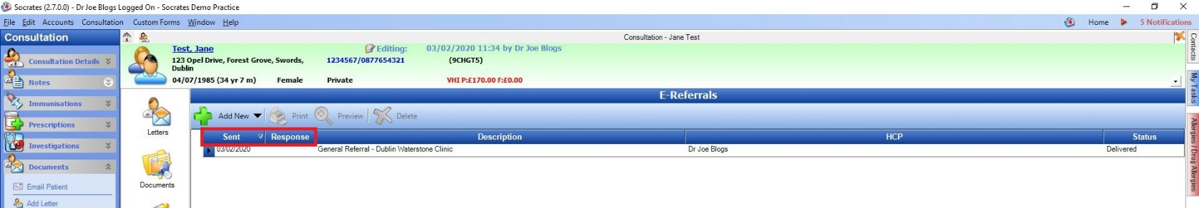

To view the response message for a particular referral double click anywhere on the referral line (highlighted in orange). The original referral letter will load up first. In the top left corner click the ‘Next’ button to move from page 1 (the referral letter) to page 2 (the response message).
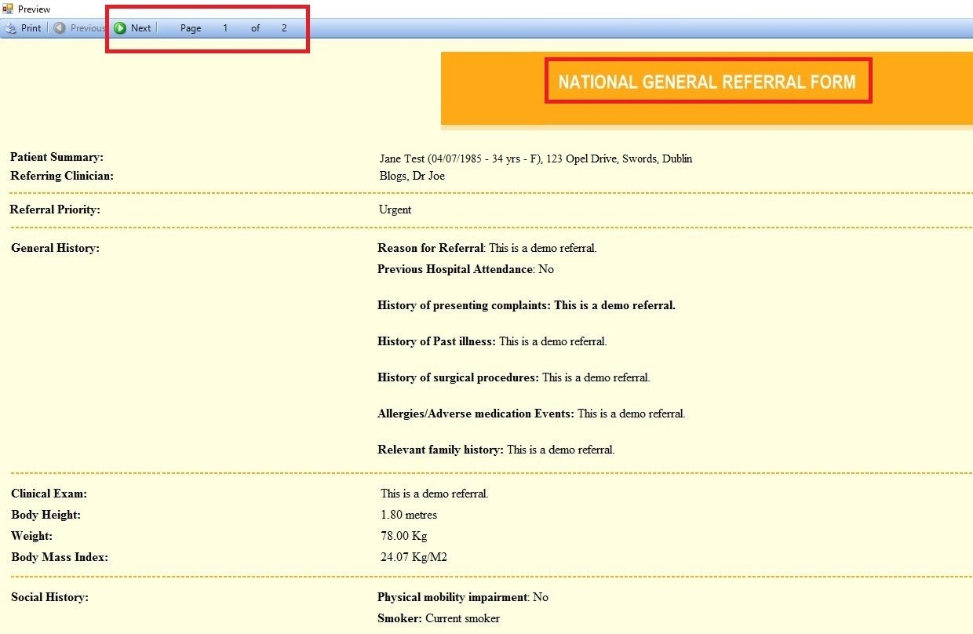

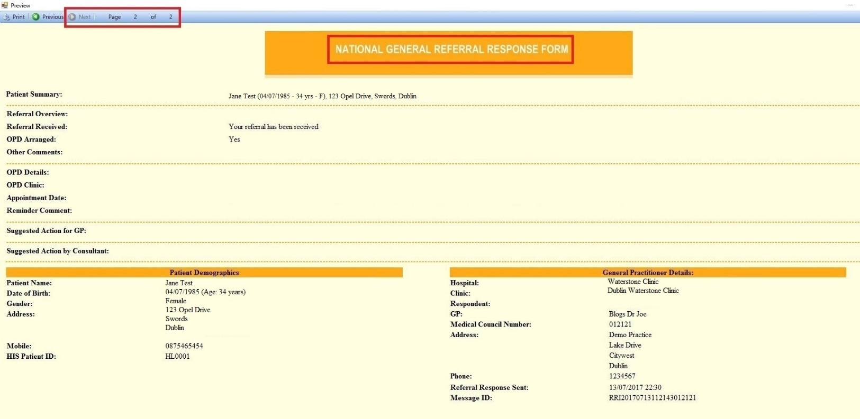

Option 2 – View response in the Result Viewer module

Step #1
Click ‘My Control Panel’ in the bottom left corner of the screen, and then ‘Result Viewer’.

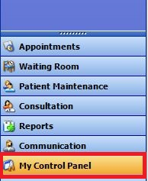

Step #2
The Result Viewer module displays all incoming electronic messages into the practice such as lab reports, COOP messages, referral response messages, etc. To view response messages click the ‘Referral Responses’ tab in the top right corner. This will allow you to view and read response messages for all patients in one convenient location.

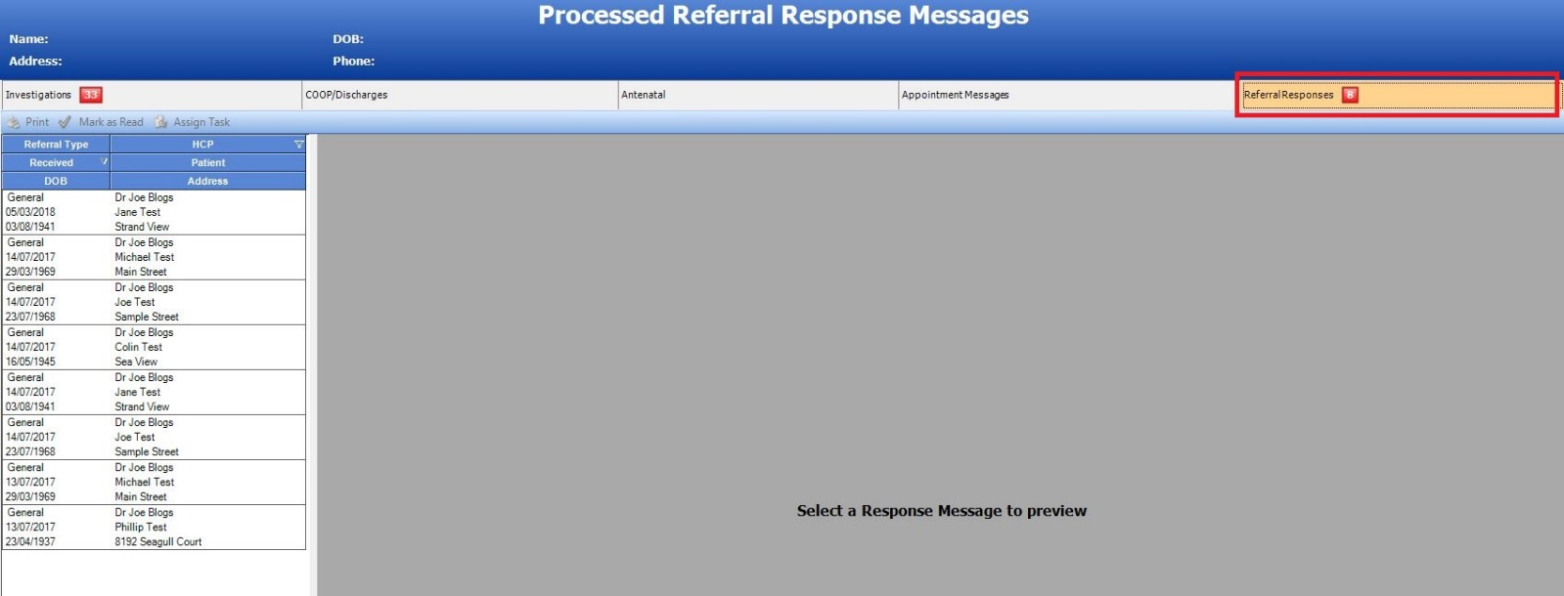

Step #3
Click a response from the list on the left hand side to view it. If you wish, you can mark it as read by clicking the ‘Mark as Read’ button in the top left corner or assign a task to action it later on. Once marked as read it will be removed from this list but will always be viewable in the patient’s chart as per Option 1 further above.

