Waterstone Clinic

Healthone GP eReferrals Mini Guide

This user guide summarises how the GP eReferral process works when referring to Waterstone Clinic via the Healthone application.

For Healthone support queries please call 01 – 463 3000 followed by option 1, or email gpsupport@clanwilliamhealth.com

Step #1
Open the ‘Healthlink’ menu at the top of the patient’s chart and click ‘Standard Referral’ if you wish to send a standard referral (e.g. Dublin Waterstone Clinic Referral).
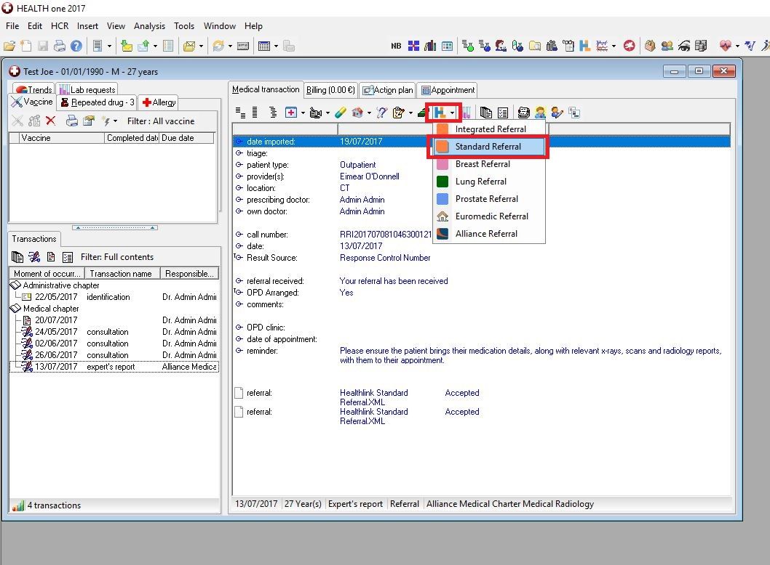

Step #2
The ‘National General Referral Form’ will load up. Select ‘Private’ Hospital Type.
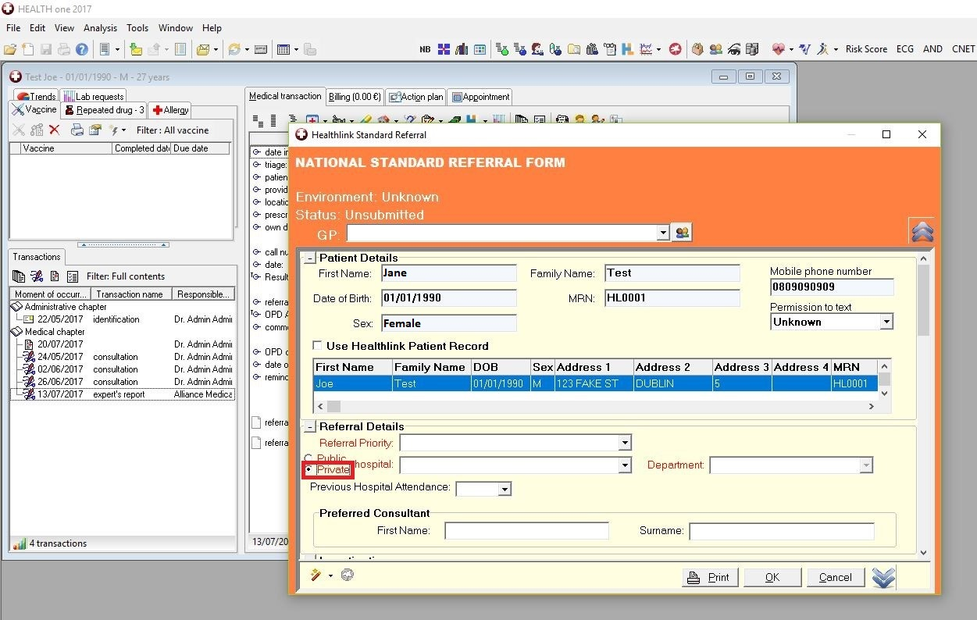

Step #3
Click the ‘Hospital’ list and select Waterstone Clinic.
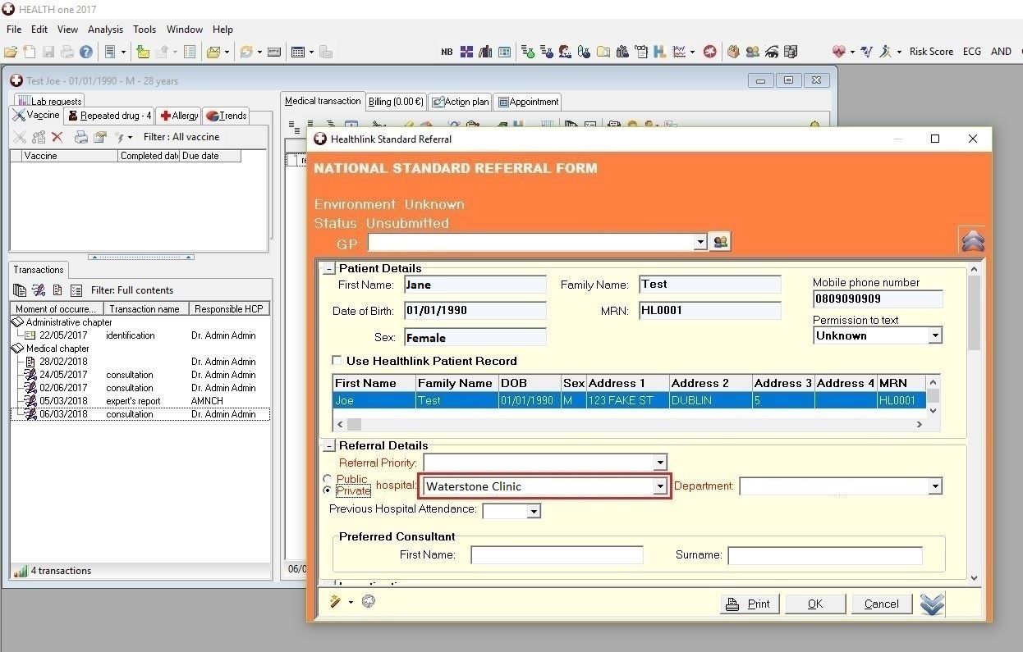

Step #4
Click the ‘Department’ list to choose what type of referral (location/service) you wish to send the patient for, e.g. Dublin Waterstone Clinic Referral.
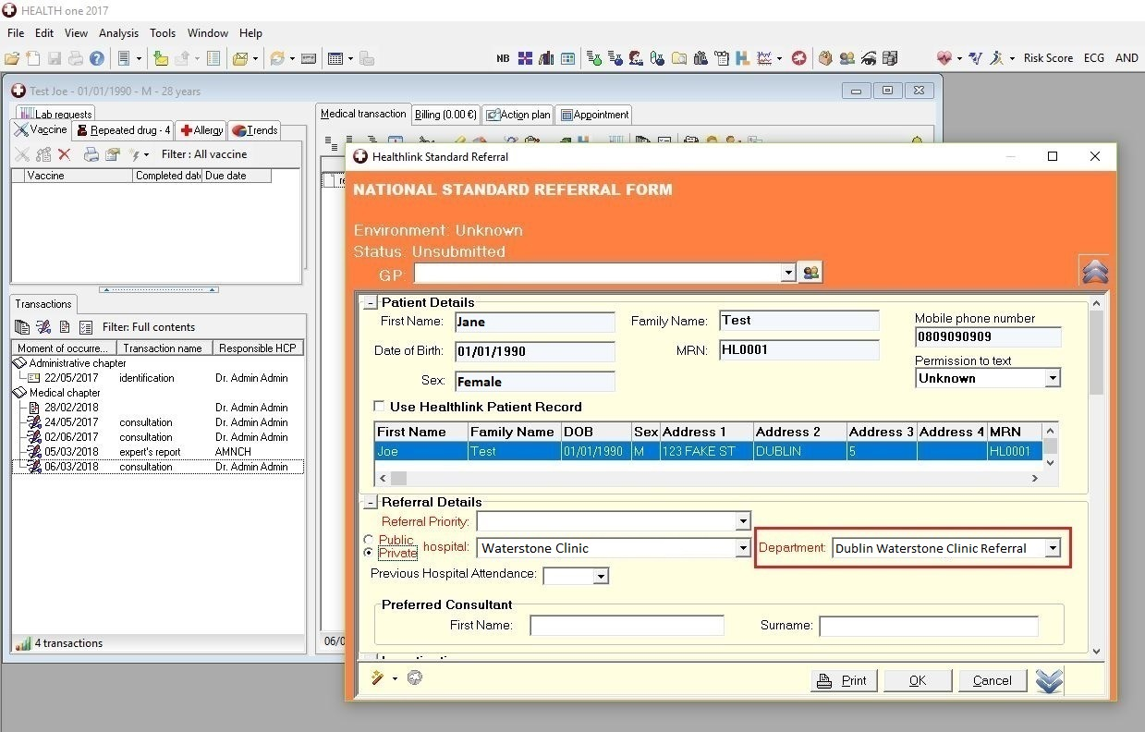

Step #5
Fill in the patient referral information as normal.
Note: demographic and clinical information, such as past medical history, medications, etc, that have already been saved in the patient’s chart will automatically populate the appropriate sections of the letter, meaning additional work/typing will be kept to a minimum.
When all referral information has been filled in click ‘OK’ in the bottom right corner.
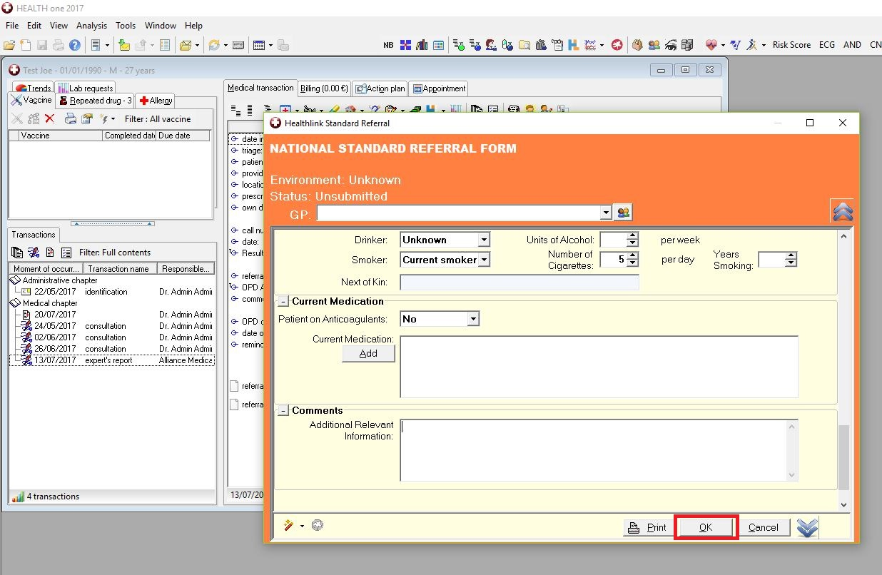

A message will appear asking if you want to send the referral now. Click ‘Yes’.
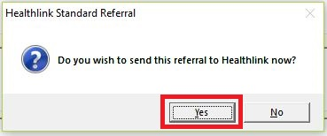

The referral will take approximately 3 seconds to deliver and will appear in the Waterstone Clinic booking office in real time where it can be triaged as normal. In the patient’s chart the status of the referral will change to ‘Accepted’.
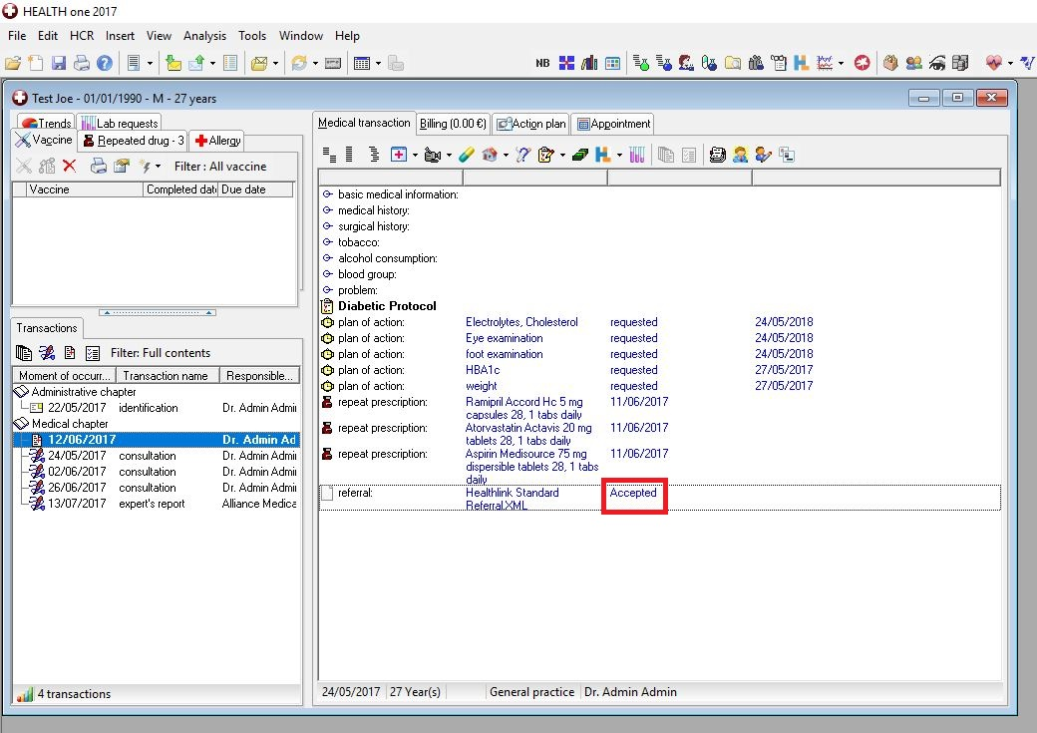

Viewing Response Messages from Waterstone Clinic

Option 1 – View response in the patient’s chart
If a referral response message is sent by Waterstone Clinic to the practice (via the Healthlink Online Portal) it can be viewed in the patient’s chart by opening the appropriate medical chapter (export’s report) from the list on the left hand side of the screen.
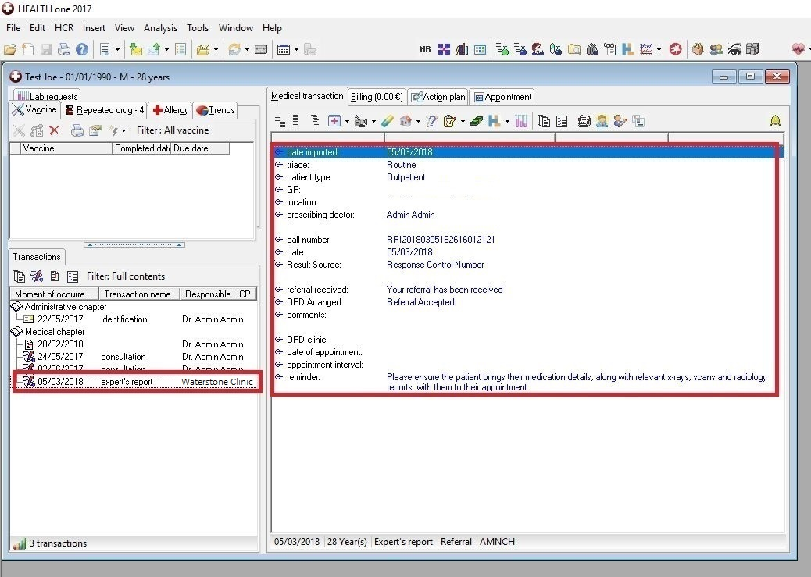

Option 2 – View response in the Data Exchange module

The Data Exchange module will allow you to view and read all types of Healthlink electronic messages, including response messages, for all patients in one convenient location.

Step #1
Click the ‘Data Exchange Module’ button in the top left corner, scroll down and highlight ‘Healthlink WebService’ and then click ‘Execute’ in the bar at the top of the screen.
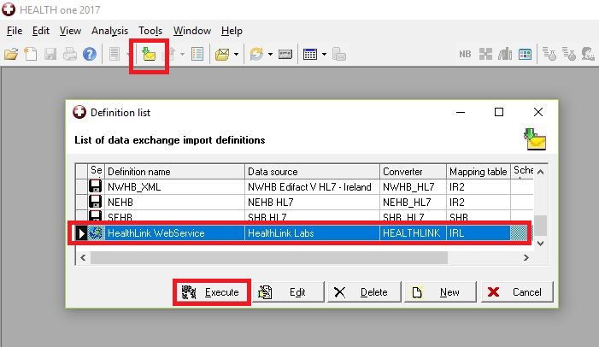

Step #2
Click the ‘Details’ button on the next screen.
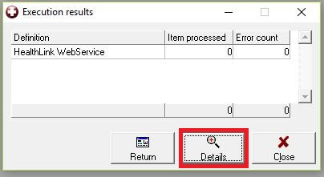

Step #3
Double click on a response message to select it and you will be redirected to the patient’s chart to view it.
