Waterstone Clinic

HPM GP eReferrals Mini Guide

This user guide summarises how the GP eReferral process works when referring to Waterstone Clinic via the HPM application.

For HPM support queries please call 01 – 463 3000 followed by option 1, or email gpsupport@clanwilliamhealth.com

Step #1
Click ‘Documents’ in the top right corner of the patient’s chart and then click the ‘Electronic Referral’ button.
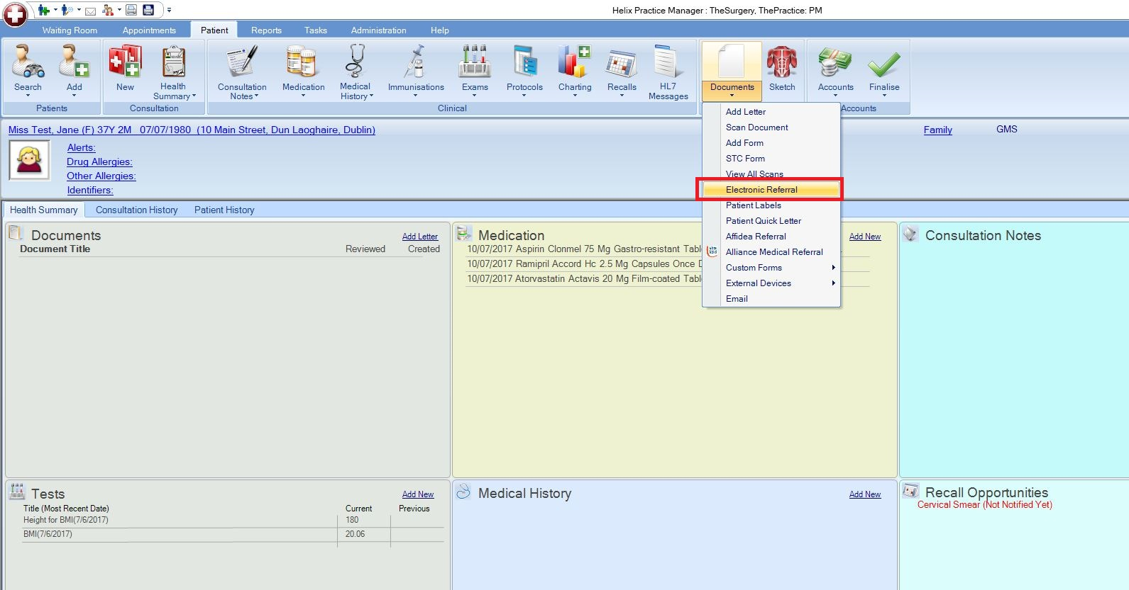

Step #2
In the bottom left corner select ‘General Referral’ from the menu if you wish to send a standard referral (e.g. Dublin Waterstone Clinic Referral) and then click the ‘Add’ button.
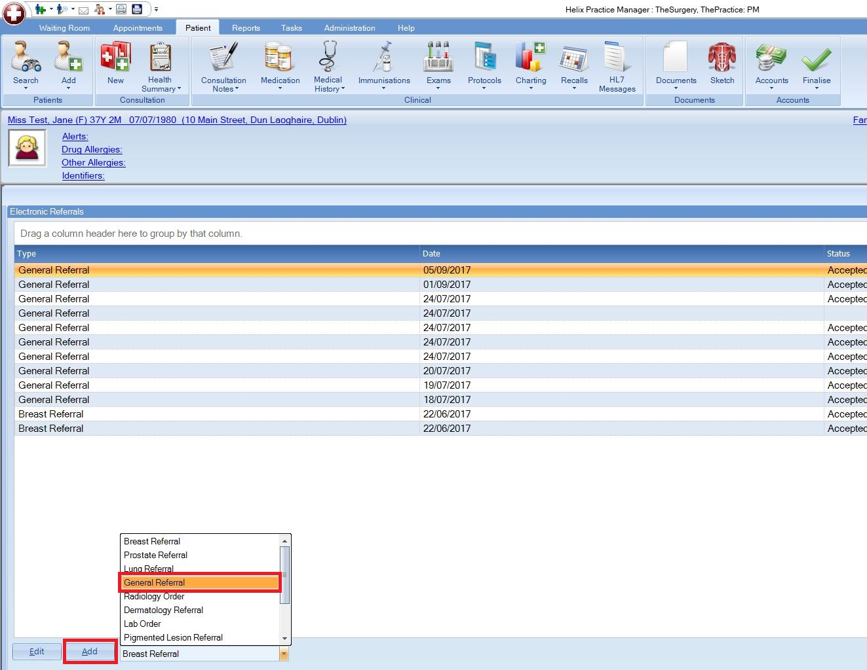

Step #3
The ‘National General Referral Form’ will load up. Select Hospital Type ‘Private’.
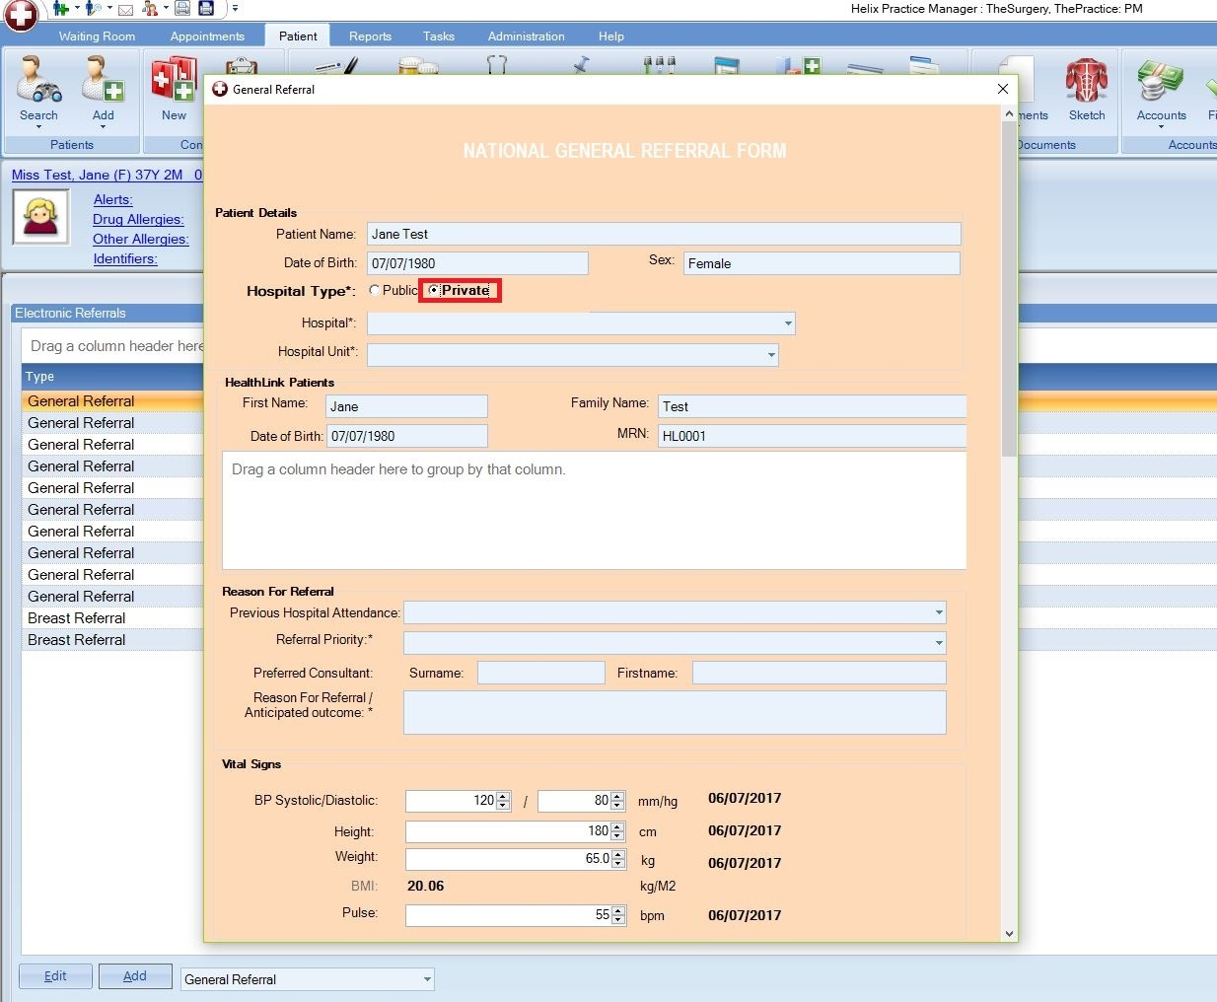

Step #4
Click the ‘Hospital’ list and select Waterstone Clinic.
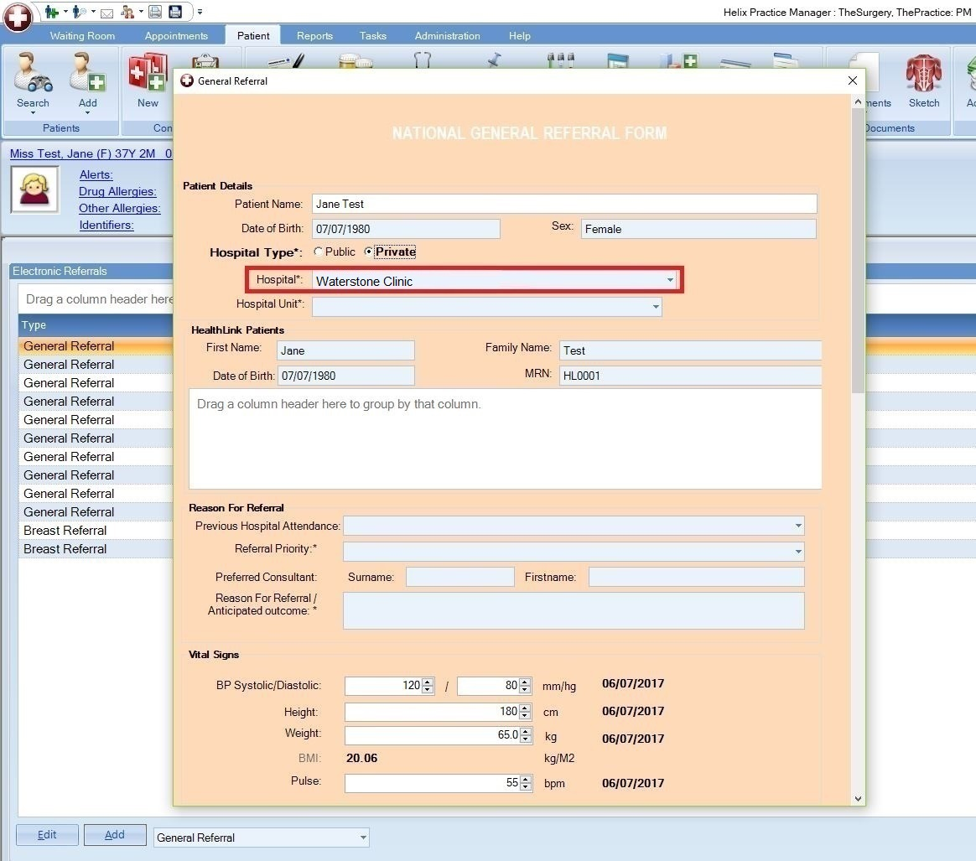

Step #5
Click the ‘Hospital Unit’ list to choose what type of referral (location/service) you wish to send the patient for, e.g. Dublin Waterstone Clinic Referral.
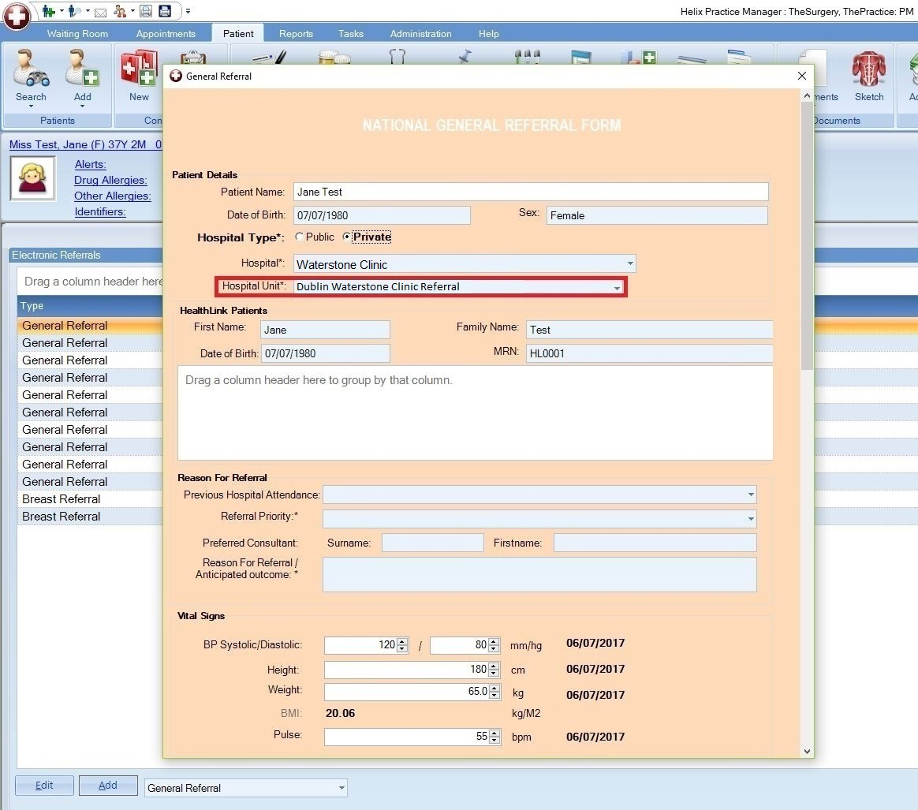

Step #6
Fill in the patient referral information as normal.
Note: demographic and clinical information, such as past medical history, medications, etc, that have already been saved in the patient’s chart will automatically populate the appropriate sections of the letter, meaning additional work/typing will be kept to a minimum.
When all referral information has been filled in click ‘Ok’ in the bottom right corner.

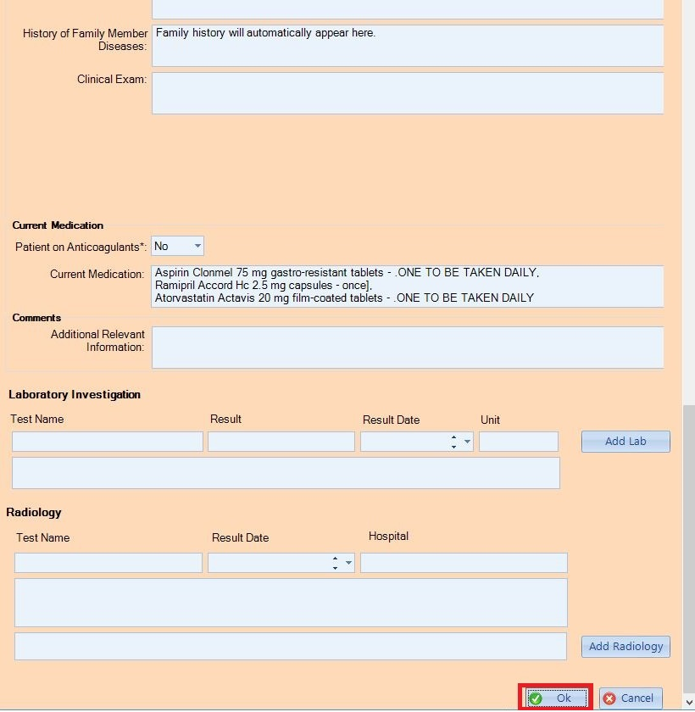

A message will appear asking if you want to send the referral now. Click ‘Yes’.
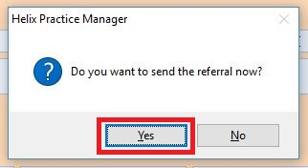

The referral will take approximately 3 seconds to deliver and will appear in the Waterstone Clinic booking office in real time where it can be triaged as normal. In the patient’s chart the status of the referral will change to ‘Accepted’.
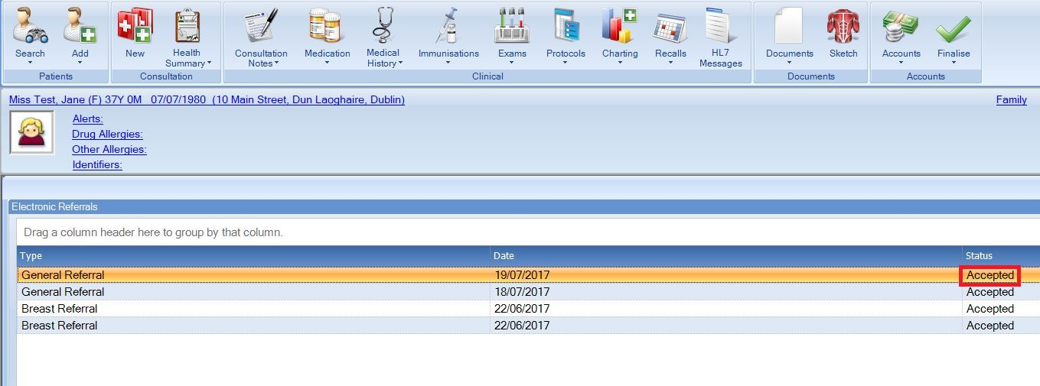

Viewing Response Messages from Waterstone Clinic

Option 1 – View response in the patient’s chart

If a referral response message is sent by Waterstone Clinic to the practice (via the Healthlink Online Portal) it can be viewed in the patient’s chart by clicking the ‘HL7 Messages’ button in the bar at the top of the screen.
In the list on the left hand side you will see a history of response messages that have come back for this patient and the date each one was received.
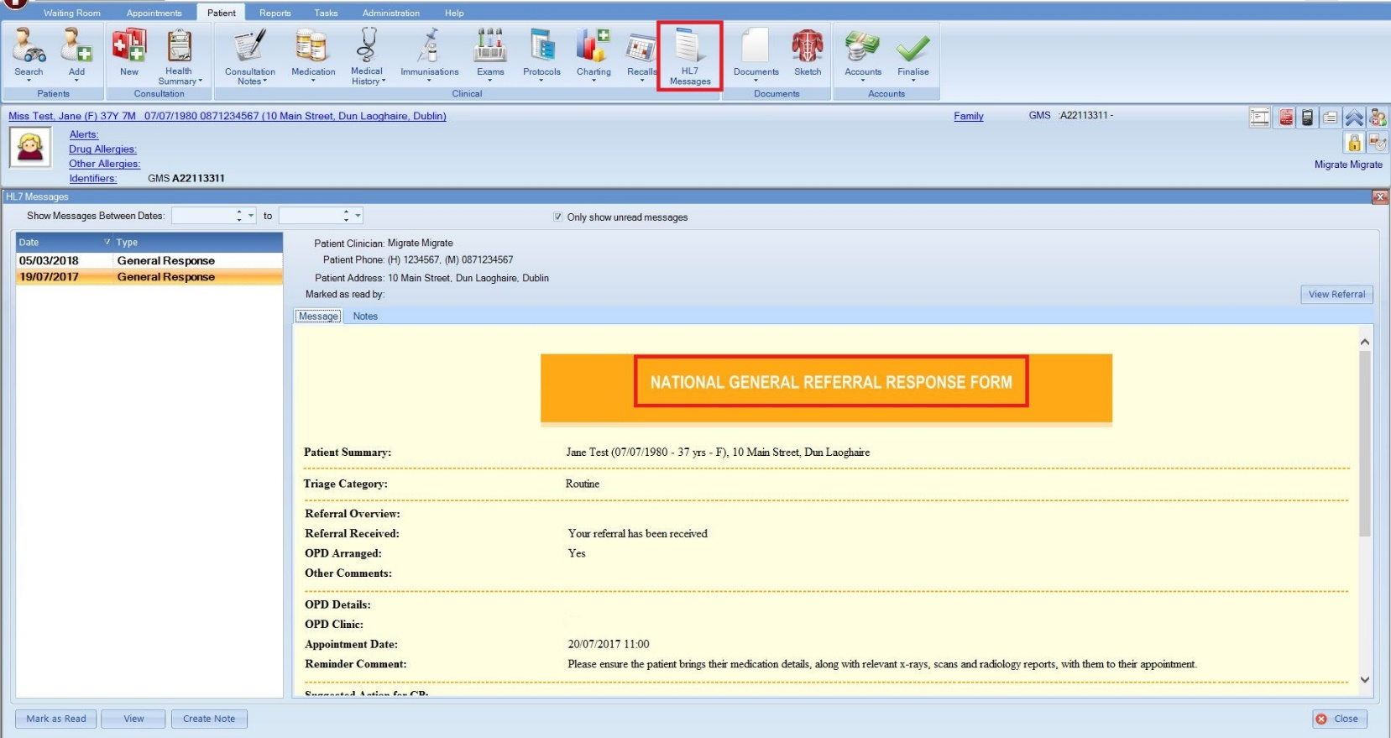

Option 2 – View response in the Unread Messages module

The Unread Messages module will allow you to view and read response messages for all patients in one convenient location.

Step #1
Click ‘Tasks’ and then ‘Unread Messages’ in the bar at the top of the screen.

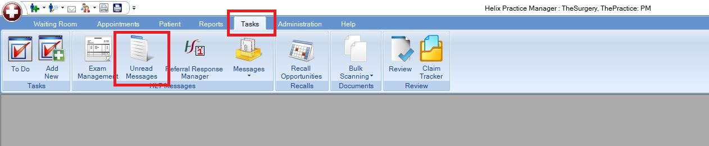

Step #2
Click a response from the list on the left hand side to view it. If you wish, you can mark it as read by clicking the ‘Mark as Read’ button in the bottom left corner. Once marked as read it will be removed from this list but will always be viewable in the patient’s chart as per Option 1 further above.

